Github:

Github.com/AnthonyYos

github.com/aaackc

github.com/s0720bae

github.com/Alshaikh1abbas

Introduction:

In our first lab our goal was to make a traffic light by using Arduino. After downloading Arduino IDE we uploaded the provided code that was given by our instructor and made adjustments for it.

Objectives:

Imitate our traffic light using LEDs, cables, and Arduino.

Approaches/ Methods:

1)Following given guidelines to achieve the main objective.

2)We changed the order in which LEDs will light first.

3)Increase the delay time up to 500 instead 250.

Workflow:

We got the cables connection wrong. After we checked with code to troubleshoot the connection, we found out that the connection wasn’t connected in the correct way. Next, we changed the connection and adjusted the code to work as traffic light.

Circuit Diagram:

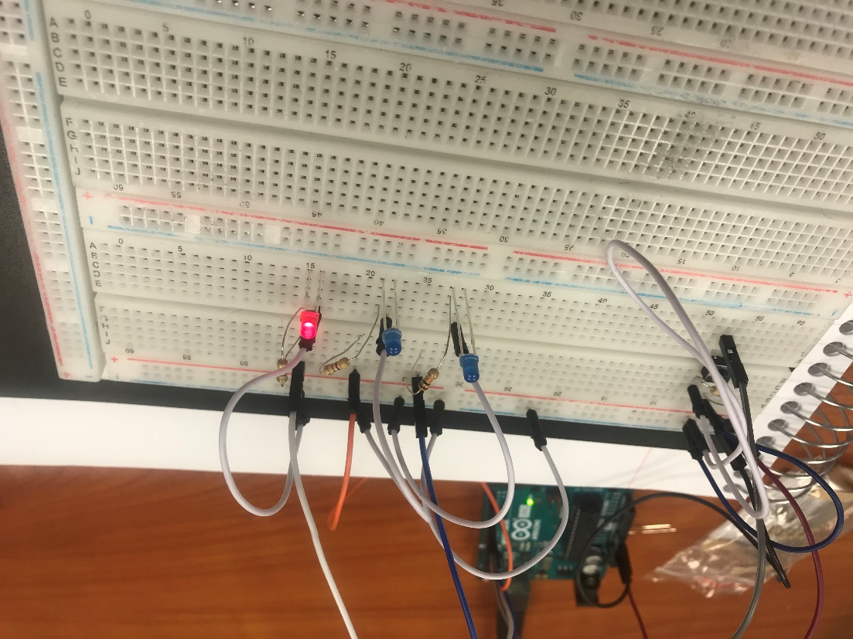

Parameters:

We changed the code and added light order and increasing the delay time.

Evaluation & Discussion:

First, we faced electrical connection issue and after help from the instructor the connection worked. We learned how to connect Arduino and circuit board and how to upload code to it. Also, we understand how adjust the code to imitate the traffic light.

Conclusion:

In conclusion, we struggled with some electrical connection experience and code adjustment; However, we learned how the power was distributed through the Arduino board and how the pin nodes’ codes could give the orders to the LED lights to be working as a traffic light.